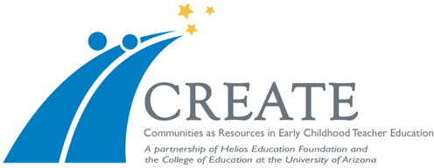

Monthly Professional Learning Opportunities (PLOs)

Cohort 9 (Elem K-3) & Cohort 10 (Birth-PreK)

December 13, 2016 - This date is purely invitational, if you want to meet your students and see their 1st semester final presentations.

The S17 meetings are:
- January 19, 2017
- February 16, 2017
- March 30th, 2017

All meetings are held in Ed North @ 1501 E. Speedway Blvd.
Parking is free in Zone 1 across the street after 5pm.

Thank you for making the time to join us!

